MUSICAL PROJECT
BUILD A CAN-TAR
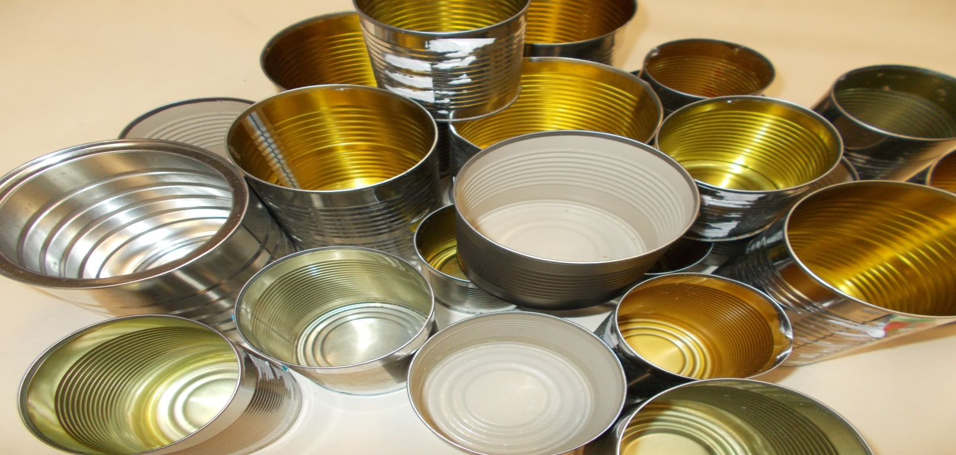

Created by Brian Allanson
SD 67 Okanagan/Skaha
ballanson@summer.com
LET’S BEGIN!!!!

TOOLS
Masking Tape Robertson Screw Driver 1/8 Drill bit
¼ Drill bit Hand Drill Ruler Pencil

MATERIALS
1 piece 2” x 21” ¾ Plywood 24” Fishing Line 1 ¼ #8 Wood Screws
1 piece 2” x 10” ¾ Plywood Tuning Peg 3/16 Flat Washer
1 piece 2” x 5” ¾ Plywood 1 Tin Can (Soup Size) 1 Fret Support Block

DIRECTIONS
LAY OUT FOR DRILLING
1). Using masking tape, mark “A” on one end of your longest piece of plywood. (2” x 21”). Mark “B” on the other end.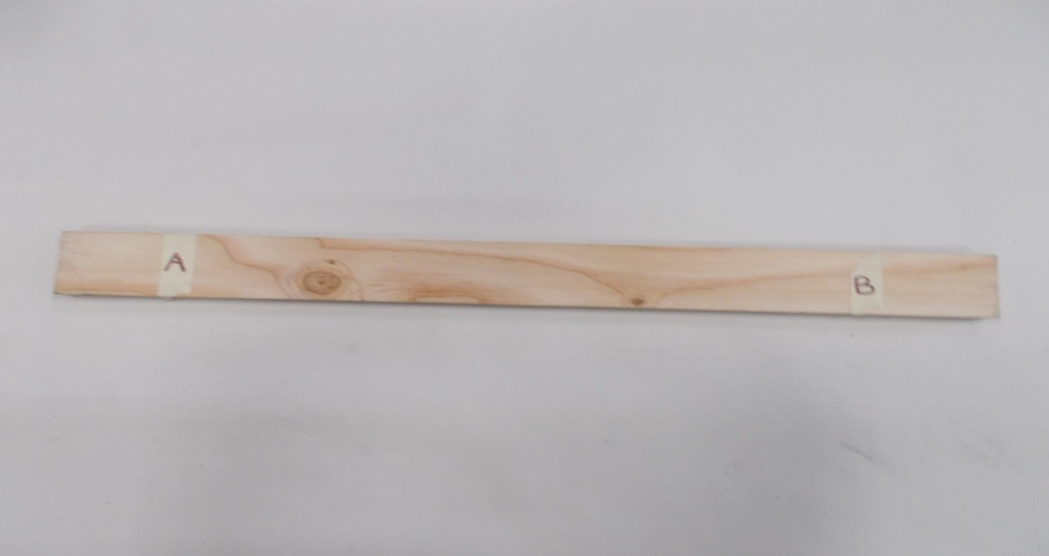

Layout the frame of the can-tar using CANTAR LAYOUT on the following page.
HINT: USE PENCIL!!! JUST IN CASE YOU NEED TO ERASE.

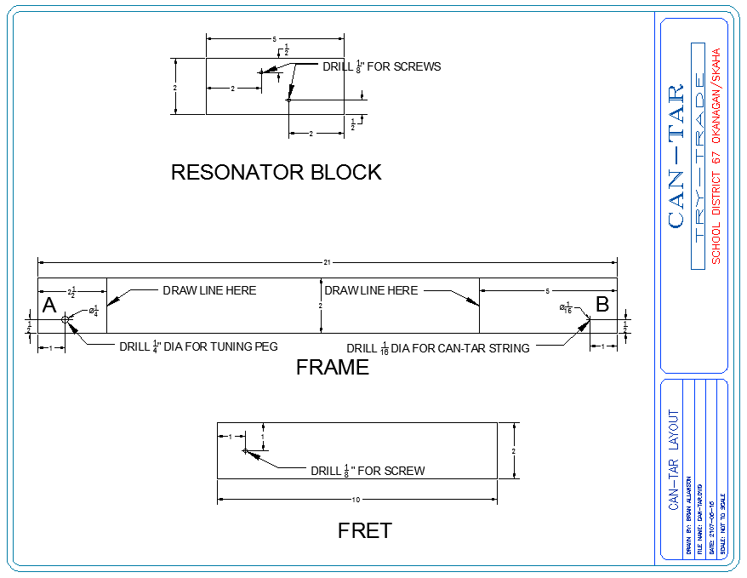
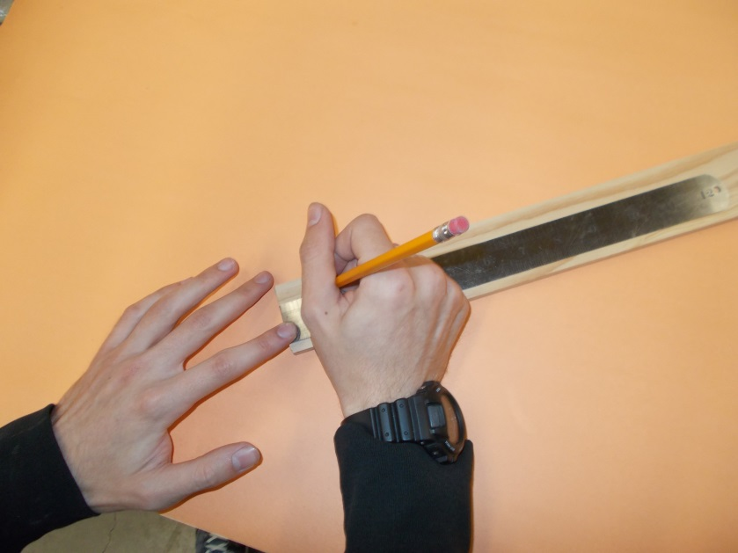

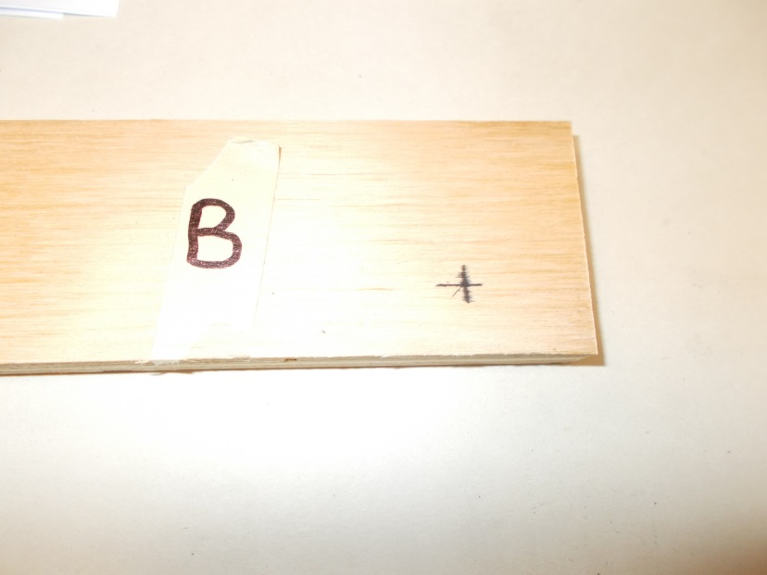

Mark your hole locations with a “t” or cross shape.

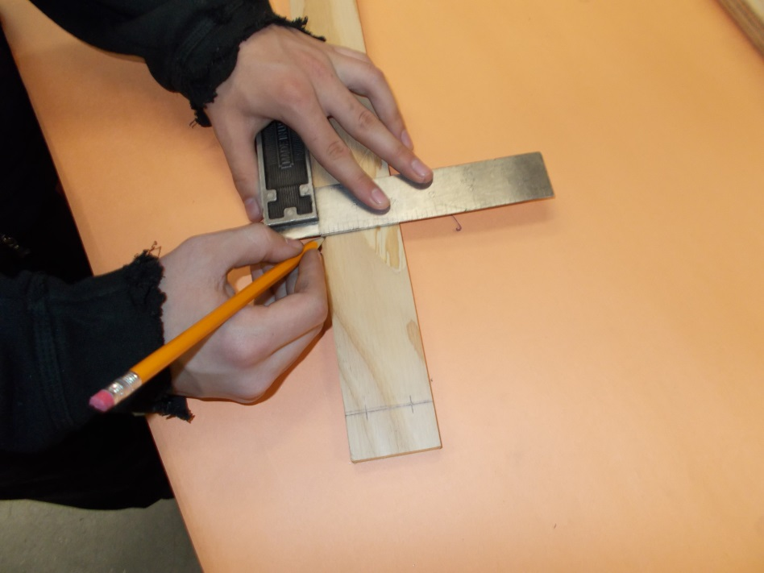

2). Don’t forget to draw lines 2 ½ inches from the “A” end of the fret and 5 inches from the “B” end of the FRET.

HINT: Always refer to the blueprint and double check your measurements!
3). Measure and layout marks for your RESONATOR BLOCK. The Resonator Block is 2” x 5” long.
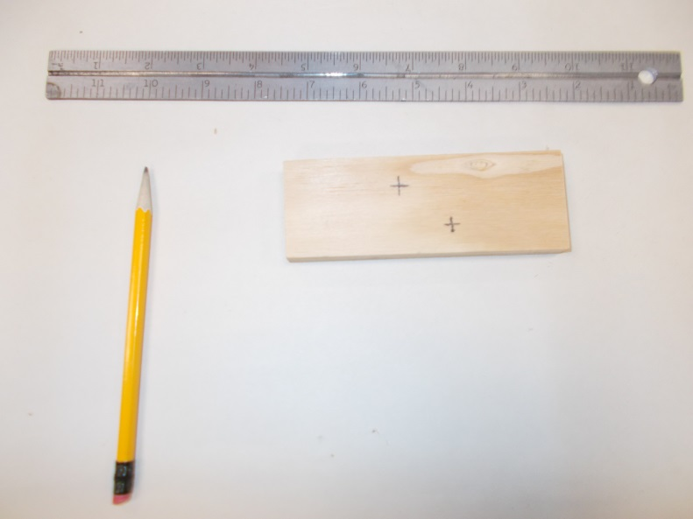

4). Measure and layout marks for your FRET. The Fret is 2” x 10 “ long.
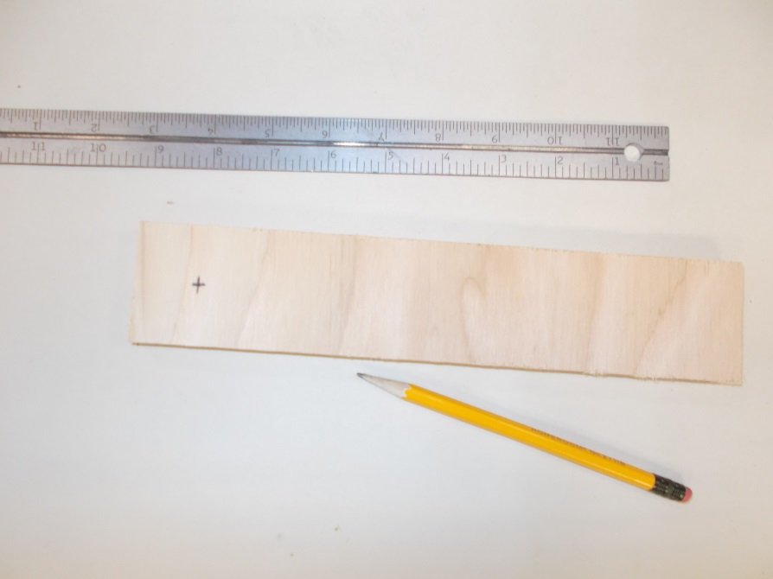

STOP!
Have your teacher check your measurements before proceeding!

DRILLING HOLES
Check with your teacher how to drill the holes.
HINT: NOT ALL OF THE HOLES ARE THE SAME SIZE! CHECK THE DRAWING AND TAKE NOTE OF WHICH SIZES BELONG ON EACH COMPONENT.
YOUR TEACHER MAY BE IN CHARGE OF DRILLING THE HOLES.
ASK!!!!!
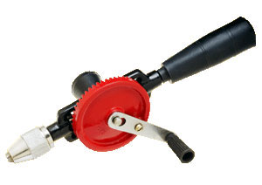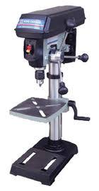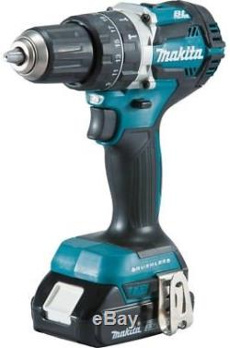

ASSEMBLY

You will need:
- Screw Driver -Wood Screws

5). Place the RESONATOR BLOCK on the “B” end of the CAN-TAR FRAME. Use the line as a reference to keep the block square and in the right position.
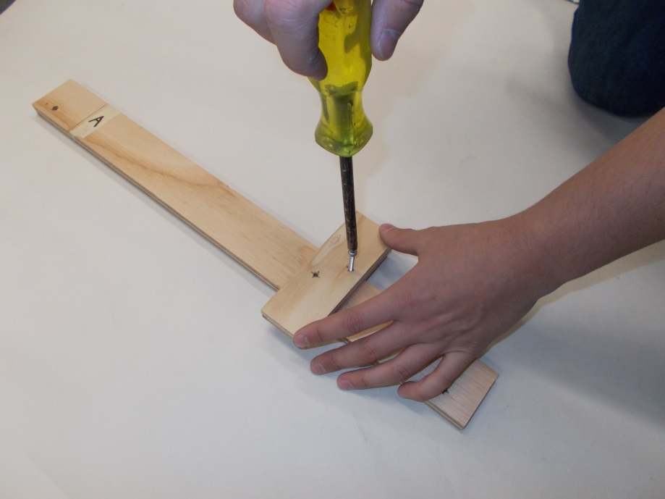

6). Place the FRET SUPPORT BLOCK on near the middle of the CAN-TAR FRAME.
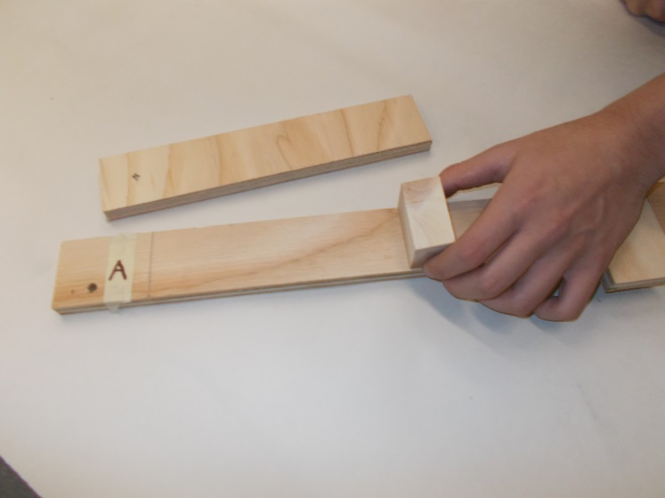

7). Place the FRET on to the CANTAR FRAME. The FRET SUPPORT BLOCK should be underneath the FRET.
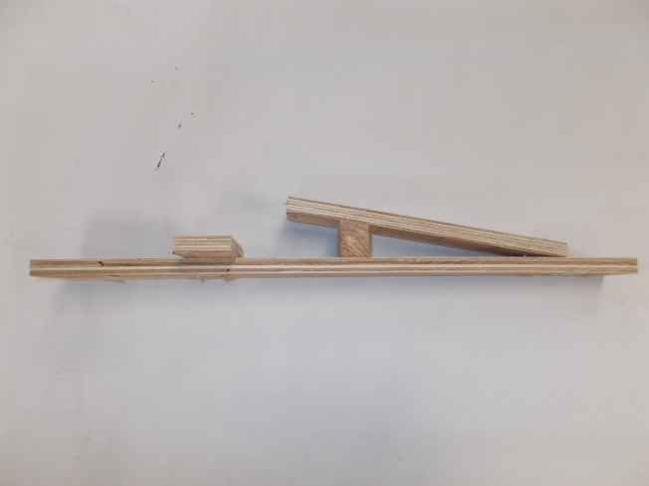
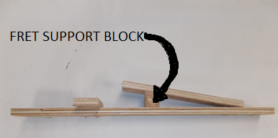

8). Screw the FRET to the CAN-TAR FRAME. Use the line on the “A” end of the CANTAR FRAME as a guide to keep the FRET square and in the correct postion.
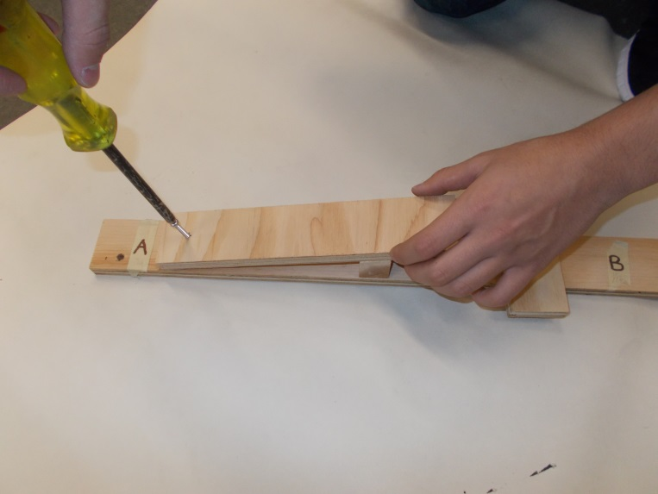

9). Push TUNING PEG from underside of CAN-TAR FRAME through the 1/4” hole.
10). Use a SCREW DRIVER to install TUNING PEG.
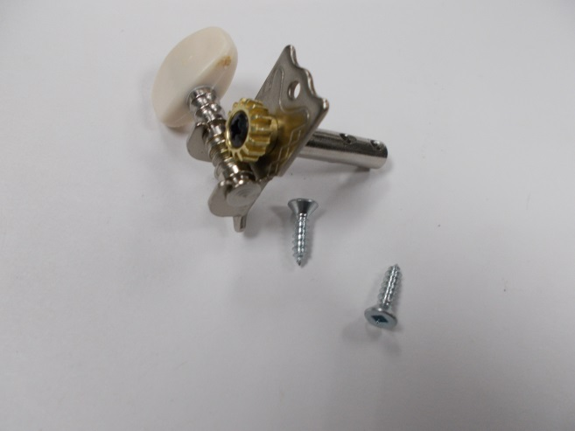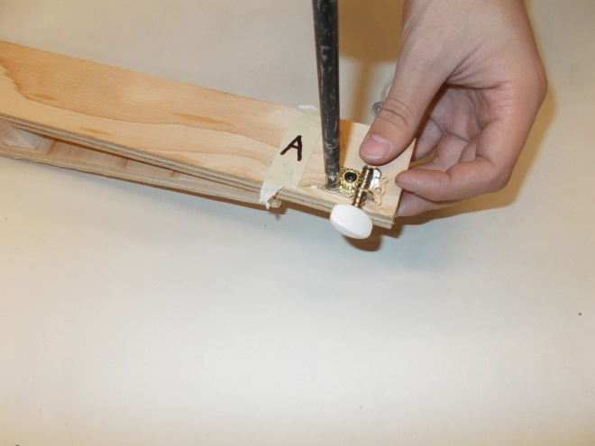

CHOOSE YOUR TIN CAN!!!!

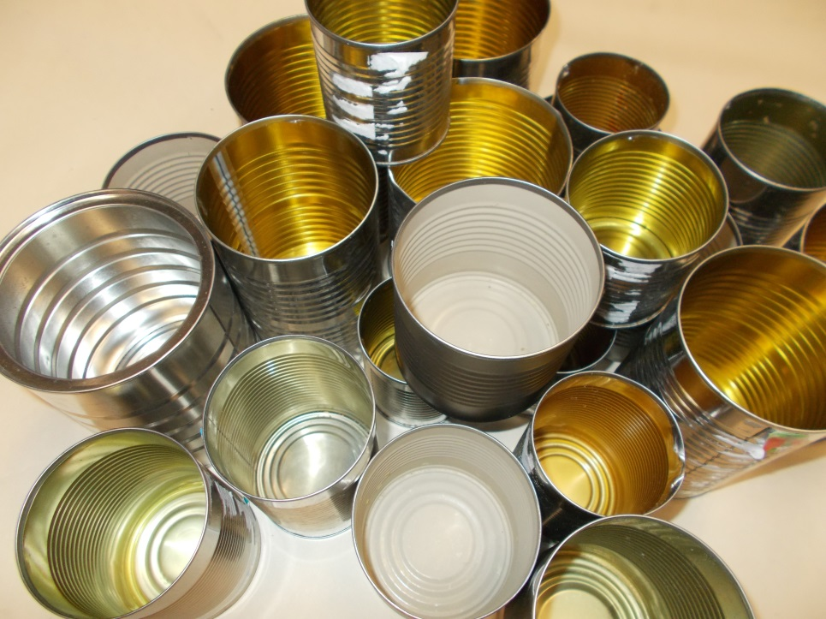

Hint: Different cans will give out different tones and sounds. Experiment with different tin cans when you take your CAN-TAR home!!!!
STRINGING YOUR CAN-TAR
You will need:
- 24” Fishing Line - Small Flat Washer

11). Tie the flat washer on one end of the fishing line.

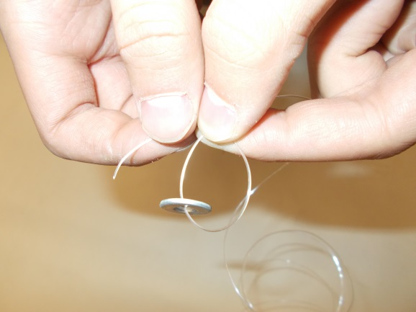

12). Feed the fishing line through the UNDERSIDE of the “B” end of the CANTAR FRAME.

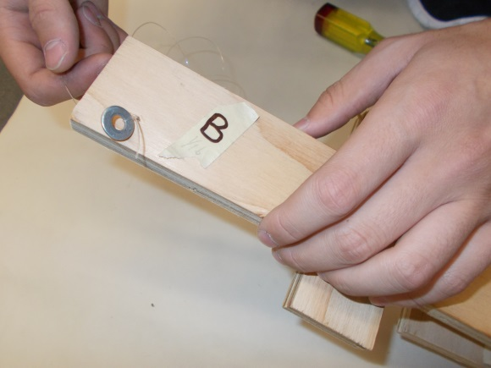

13). Bring the Fishing line over the TIN CAN and through the hole in the TUNING PEG.

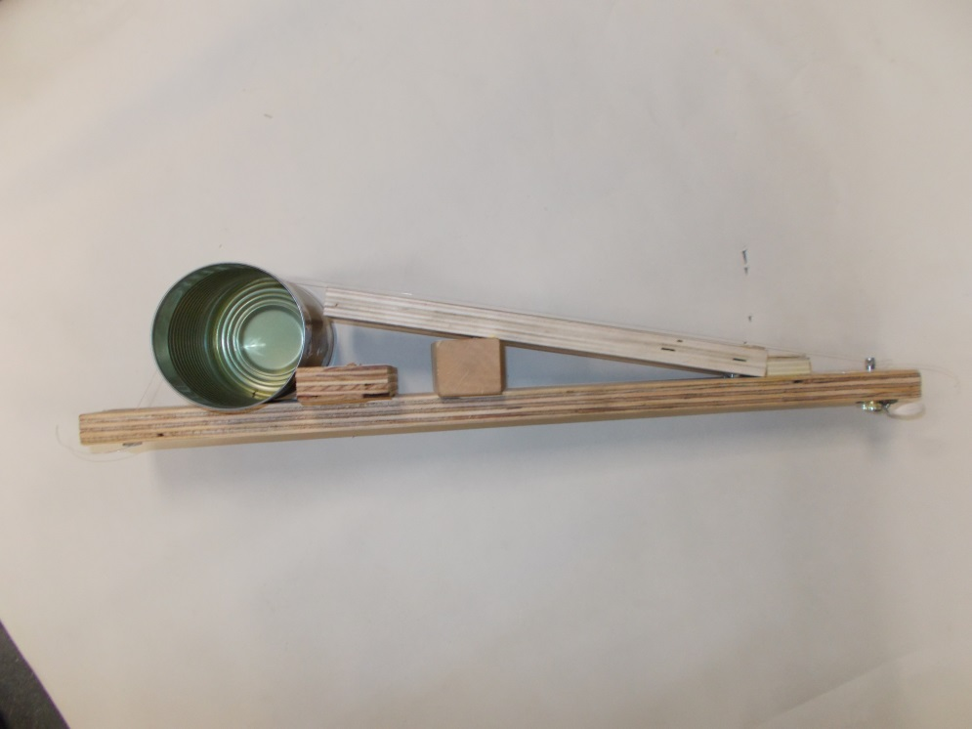
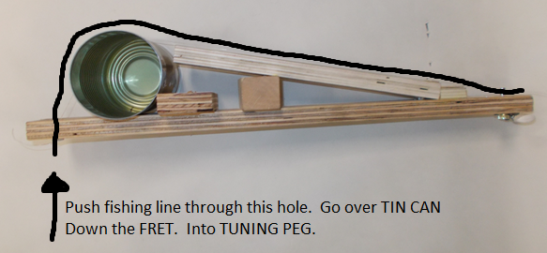

14). Turn the TUNING PEG in a clockwise motion or counter clockwise motion to tune your CAN-TAR.
YOU ARE FINISHED CONSTRUCTION OF YOUR CAN-TAR!!!

