MORSE CODE
CHALLENGE
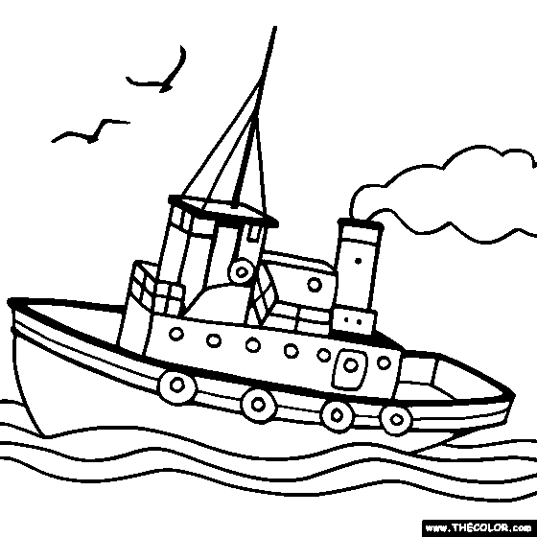

Created by Brian Allanson SD67 Okanagan Skaha
ballanson@summer.com
The Challenge:
To build a Morse Code machine that will enable you to communicate across the room without seeing the other person.

Tools and Materials:
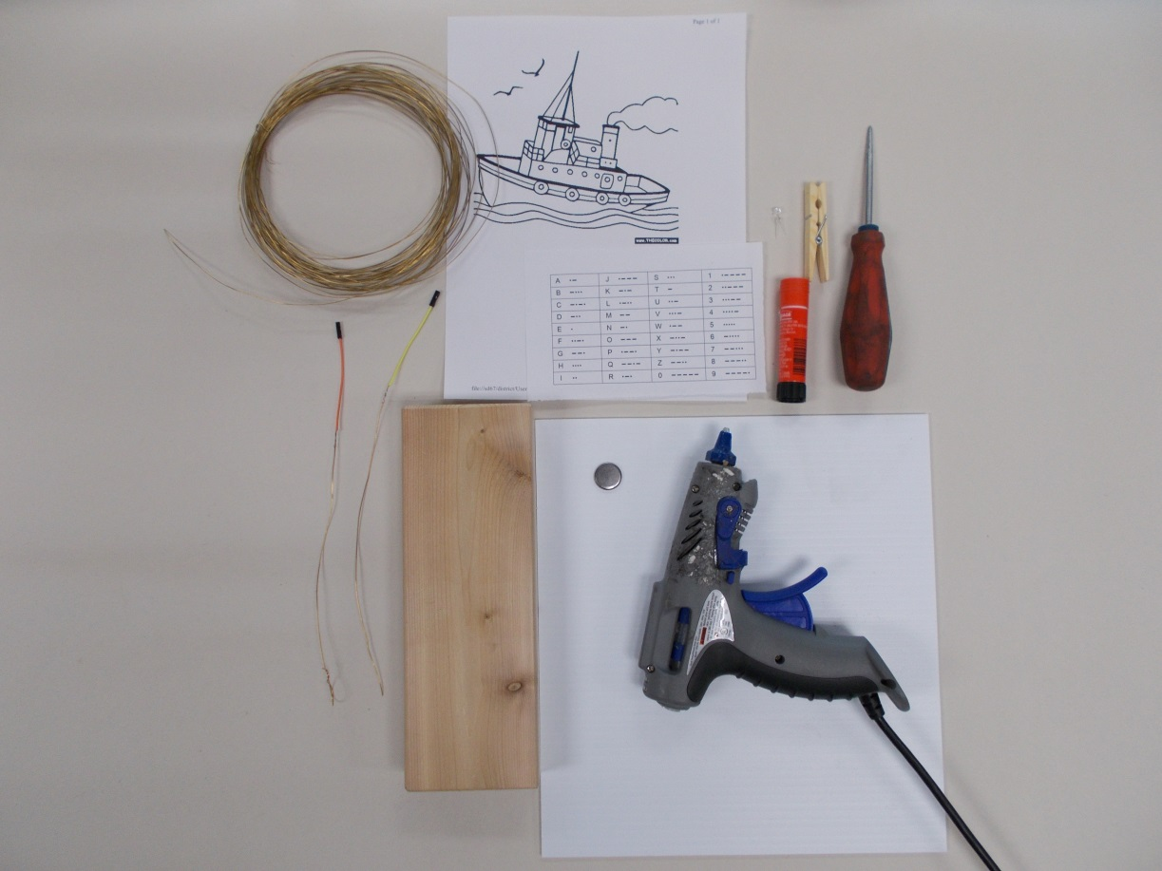

-Hot Glue Gun - Wire - Glue Stick - Awl
- 3V battery - 2x4 (12” or so) - Clothe Pin - 12”x12” cardboard
- LED circuit - Graphic - Crayons -Morse Code chart

STEP ONE: Choose a picture of a boat or other.
STEP TWO: Colour your picture. You could use crayons, pencil crayons, paint, or other.
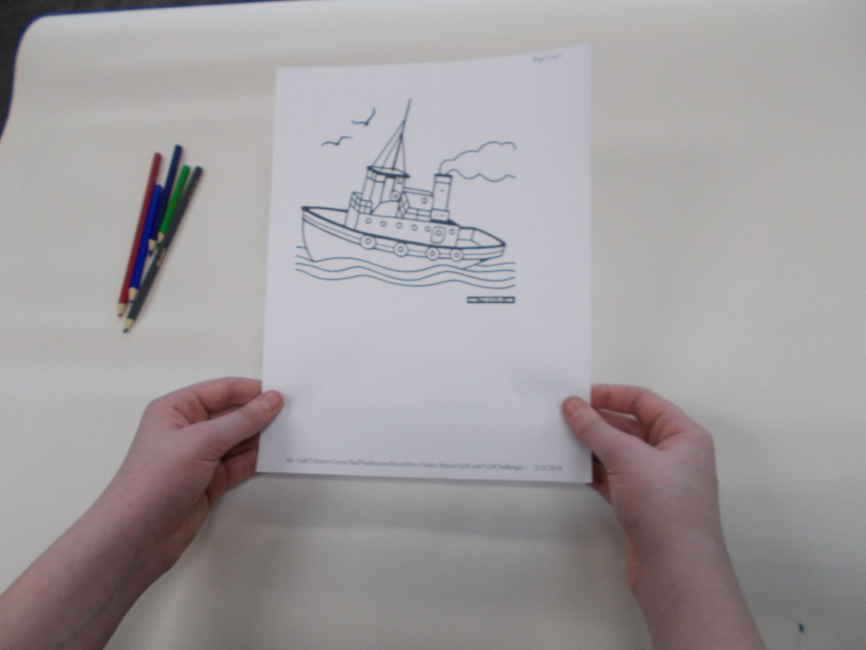

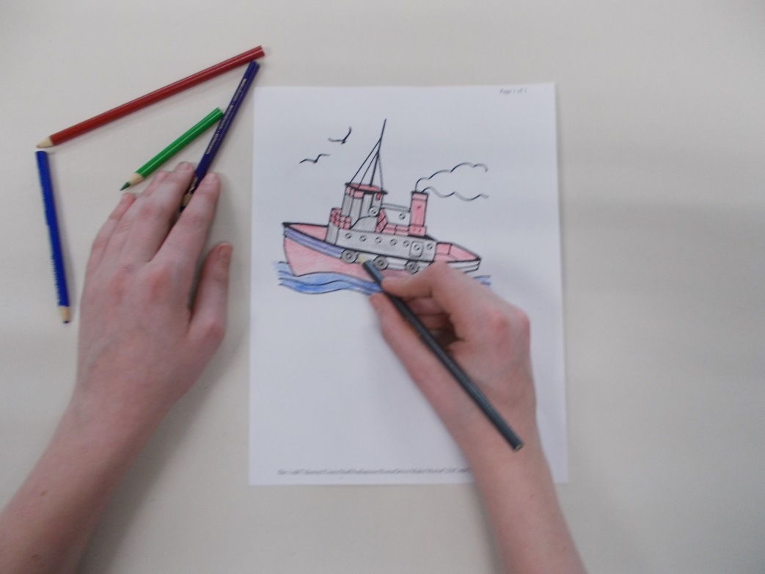
STEP THREE: Glue your picture to a piece of 12” x 12” cardboard.
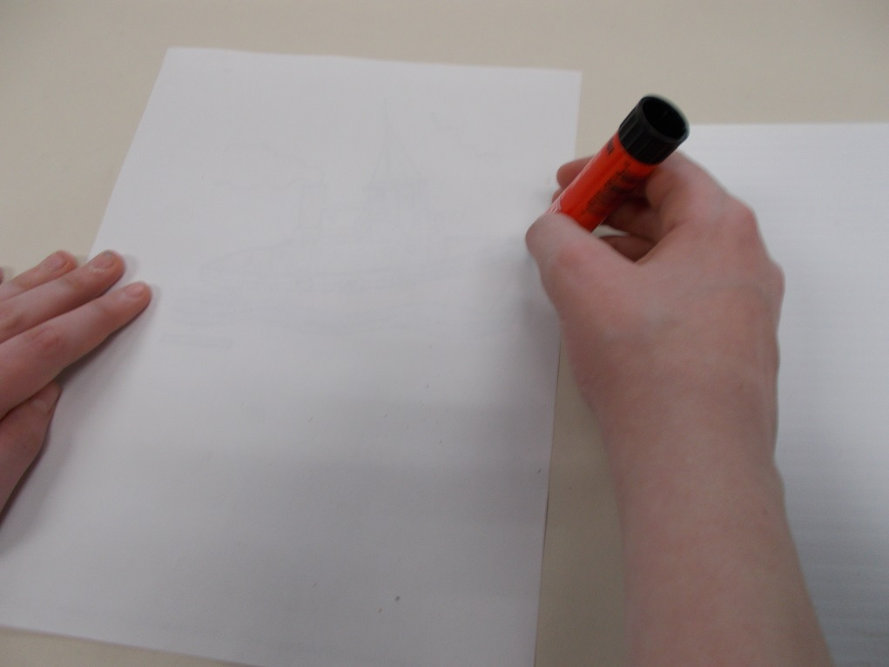

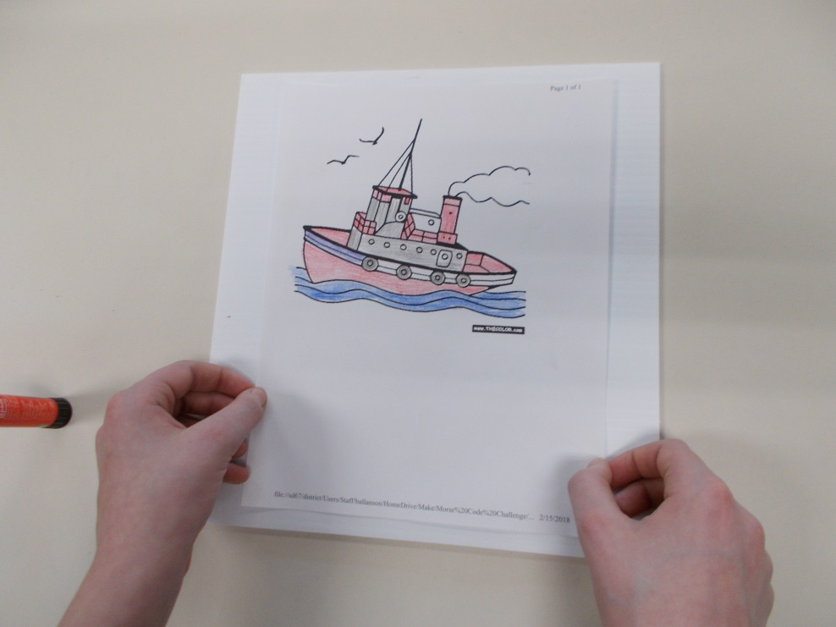

STEP FOUR: Choose location for LED light to be mounted on your picture. Use an AWL to poke a hole through your picture.
BE CAREFUL!!!!!
PLACE PICTURE ON A FIRM SURFACE AND APPLY PRESSURE TO AWL.
ONCE YOU ARE PART WAY THROUGH, MOVE HOLE JUST OFF SURFACE AND PUSH AWL THROUGH.
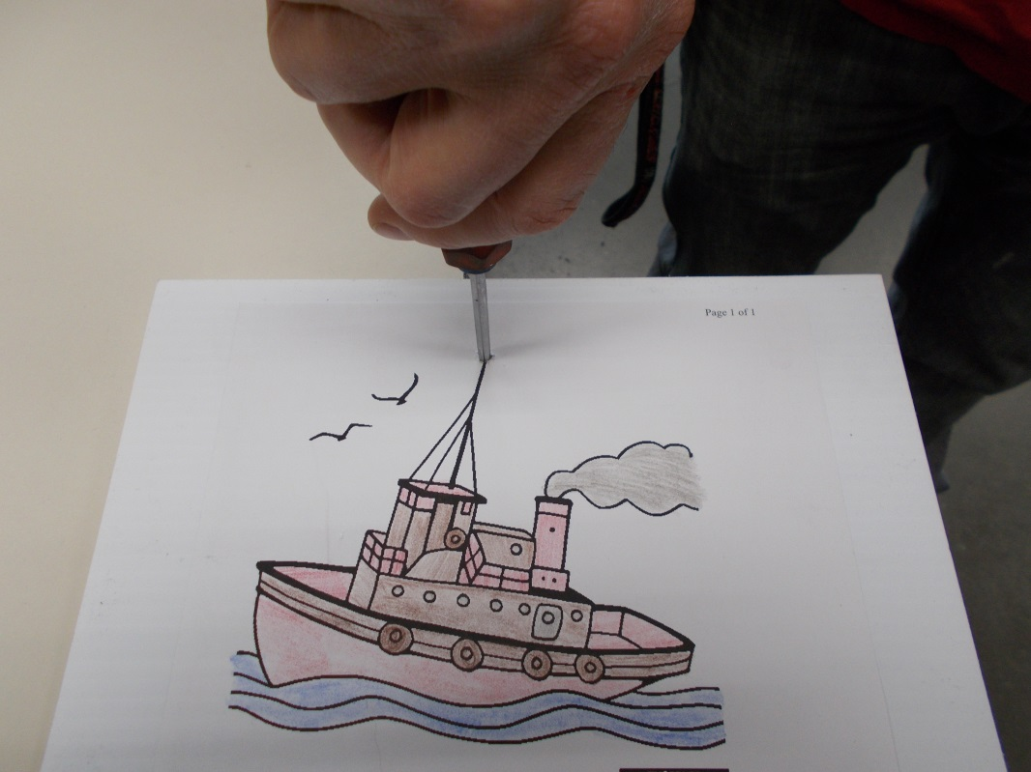
ASK YOUR TEACHER FOR HELP!!!!

STEP FIVE: Use Hot Glue Gun to attach cardboard to edge of 2x4.
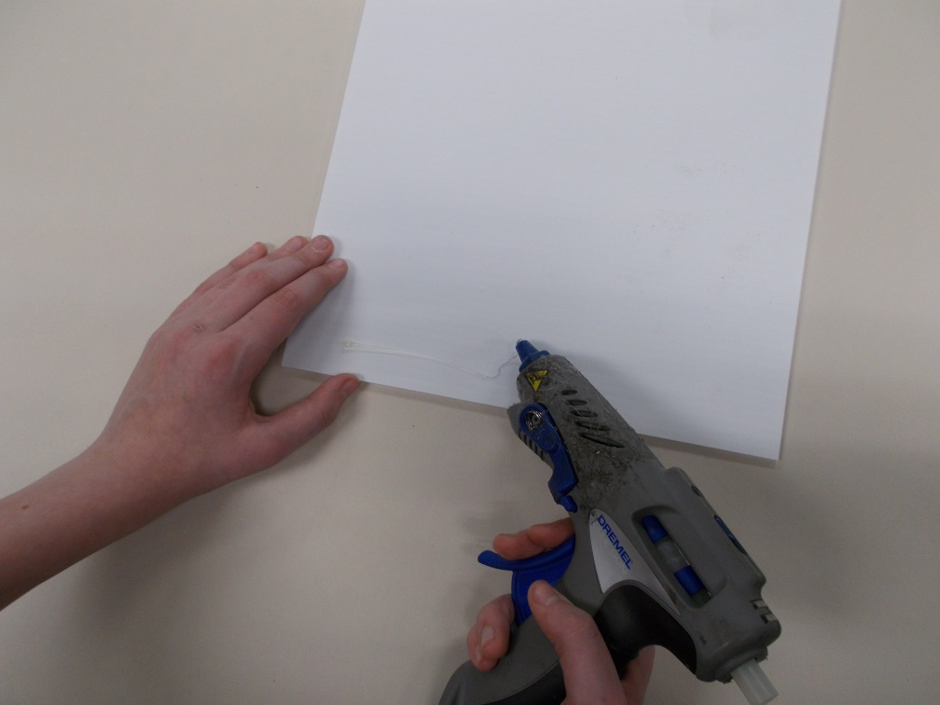

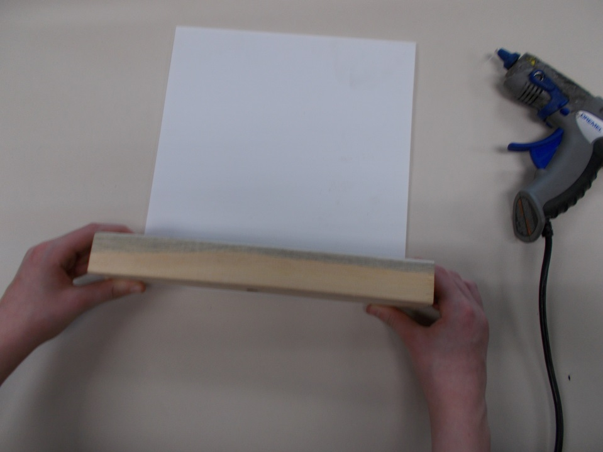

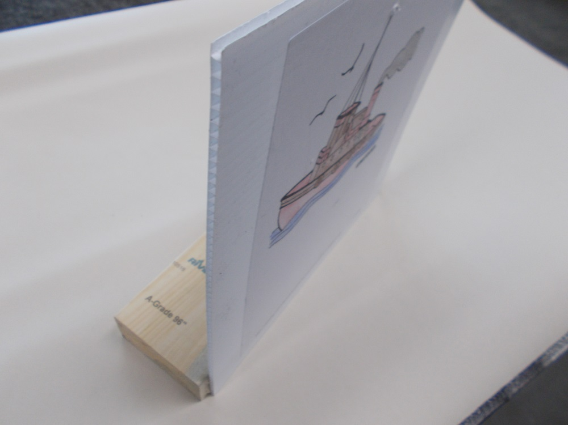

STEP SIX: Make electrical circuit. Begin with battery snap. Push short wire through hole on one side of clothes pin. Wire should protrude about 3 cm. Wire should come out from the side of the clothes pin. Twist wire firmly.

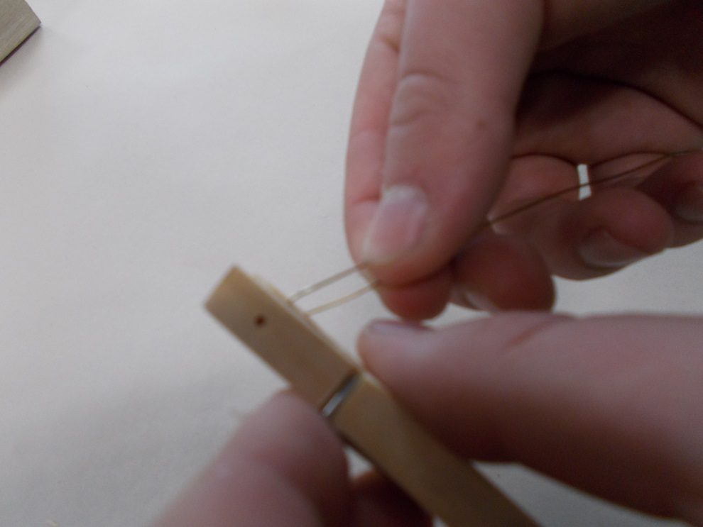
STEP SEVEN: Repeat STEP SIX to make opposite side of battery snap. Locate long wire with LED attached. Use the same method as STEP SIX and twist LED wire to other side of clothes pin.

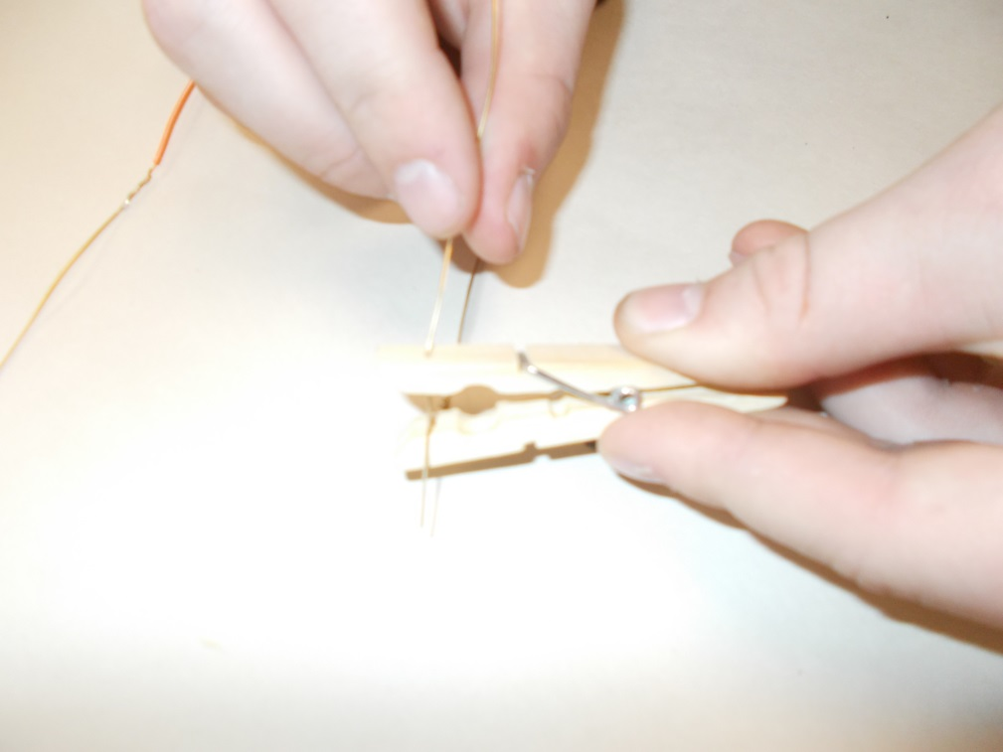

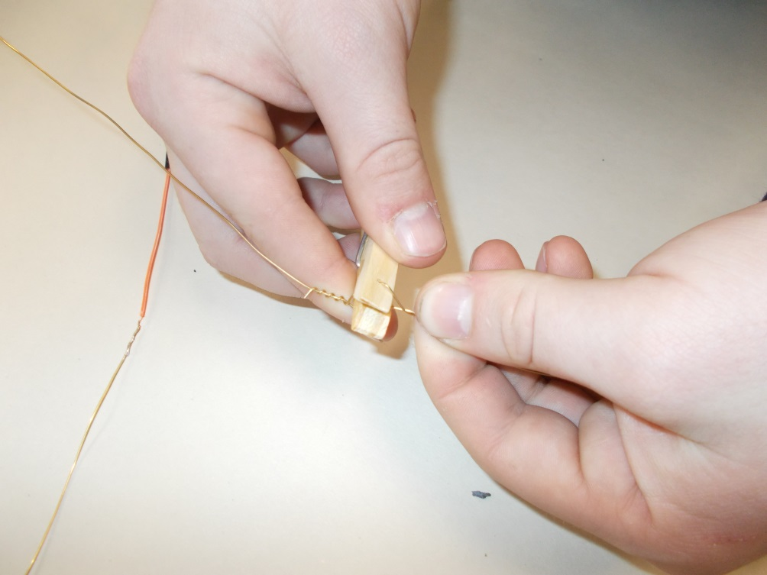
STEP EIGHT: Complete circuit. Choose LED. Install LED into sockets. Install battery into battery snap. Test circuit by touching switch wires together.
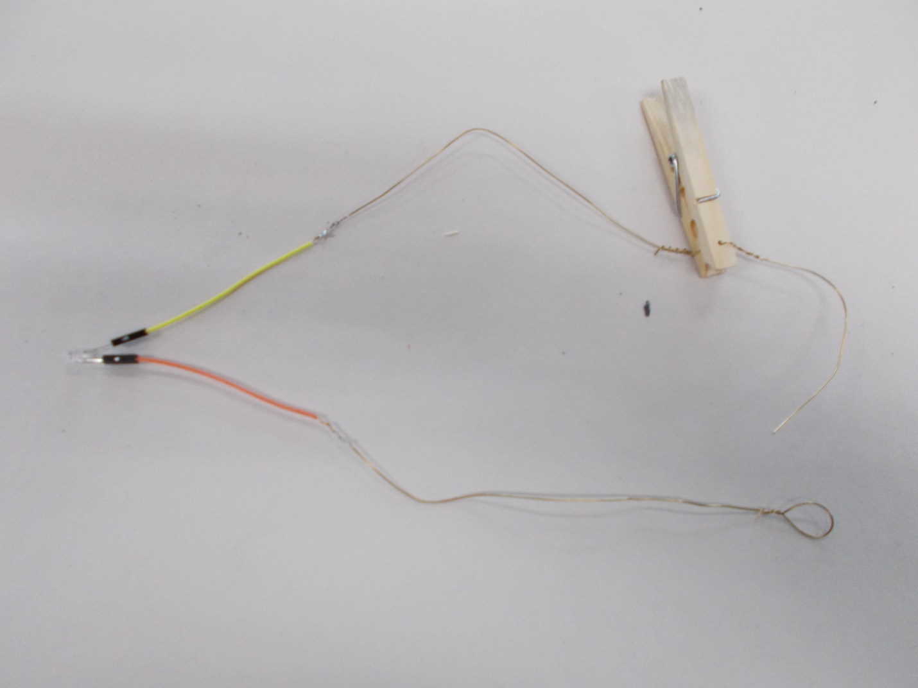

BATTERY SNAP

ADD BATTERY HERE
LED LIGHT
TOUCH THESE WIRES TOGETHER

NOTE: If your led doesn’t’ light up, flip your battery over in the battery snap.

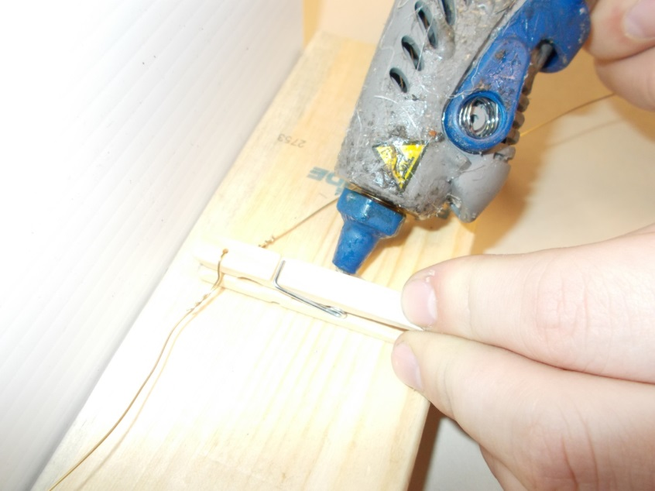
STEP NINE: Using a HOT GLUE GUN, locate and glue the BATTERY SNAP to the 2x4. Remember to leave enough room to also glue down the short wire for the switch.

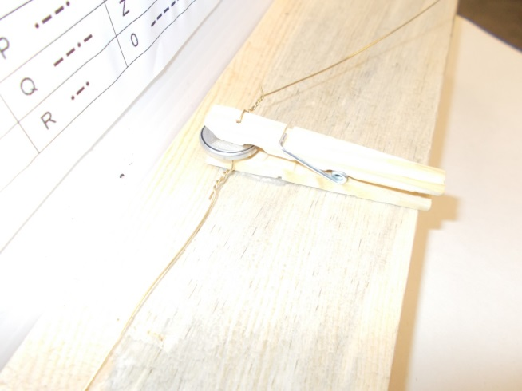

STEP TEN: Create switch mechanism. Using HOT GLUE GUN, glue the very end of the short wire to the 2x4.

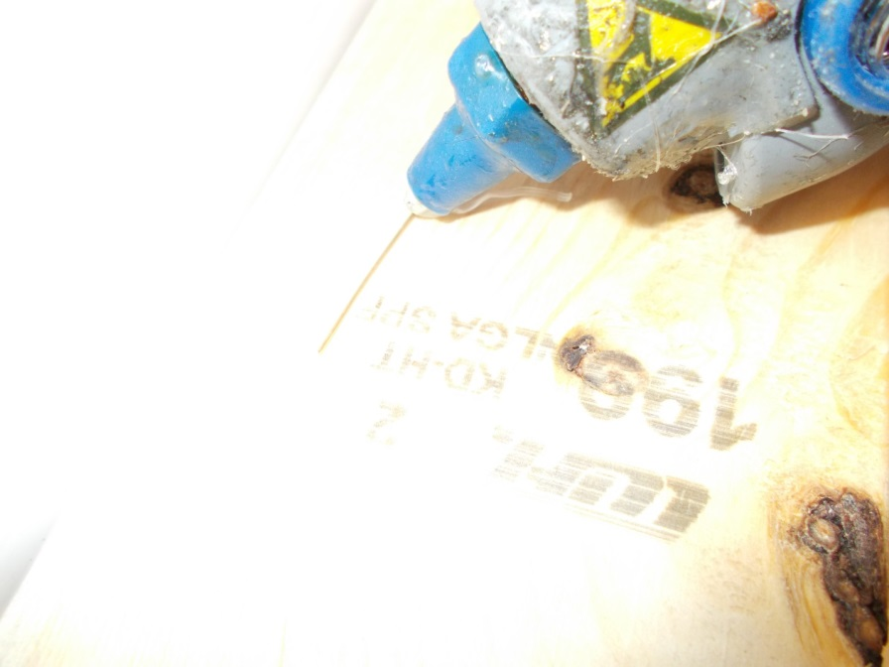
STEP ELEVEN: Add Morse Code chart to back side of cardboard. You will need to create and decipher Morse Code. By adding a chart to the back side of the card board, you can easily send and receive messages.
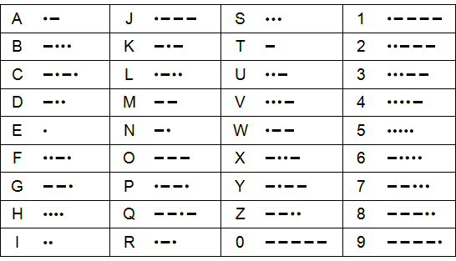

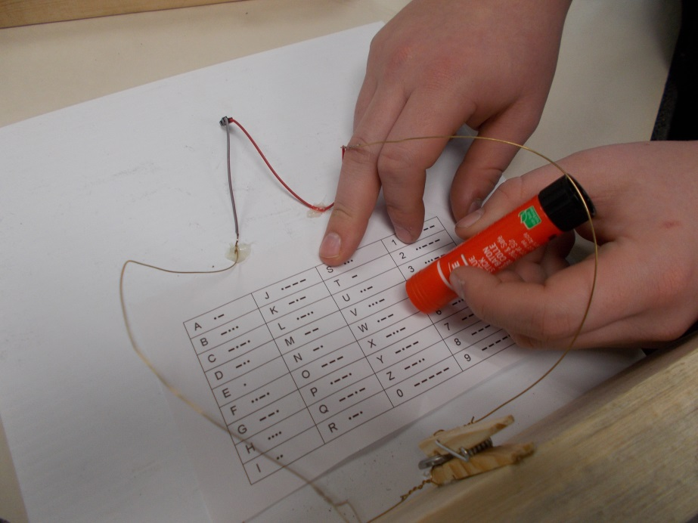
STEP TWELVE: Glue your finished circuit to the cardboard. You may need to poke your LED through the hole from the front. Connect your LED to the sockets. Using a HOT GLUE GUN, neatly glue your electrical circuit into place.
YOUR MORSE CODE MACHINE IS COMPLETE!!!!!
HAVE FUN. CREATE AND PRACTICE WITH SMALL WORDS AT FIRST. WORK YOUR WAY TOWARDS SENTENCES.

